# EECS 4421 Assignment 3

## Mahfuz Rahman

## 217847518

1. Obtain a jpeg or similar blueprint of some constructed space. Something of reasonable complexity, but at least 20m x 20m as a jpeg or similar image. Scan this as an image where the size of a pixel is approximately .1m. This means your image will be at least 200x200 pixels in size. You will use this blueprint in two ways. (i) to build a Gazebo model that is consistent with the blueprint, and (ii) to do planning for a laser-equipped robot in this space. [no marks]

Blueprint:

1. Construct a Gazebo world from the blueprint. To do this, define a north on your blueprint and run gazebo. Gazebo has a "Building Editor" within it which you can use to import the blueprint and draw walls on it. So for the example above, one would import that and draw 'interesting walls' for the robot. One might leave out all the uninteresting furniture, only keep walls (and doorways which are assumed to be open), remove doors, etc. For ease of use, assume a single floor. Note that you cannot edit what you have created once you exit the editor, but you can merge worlds together and you can manually edit the world file. To launch gazebo with no world just run 'ros2 launch gazebo_ros gazebo.launch.py'. And once you have built a world, you can launch gazebo with the word using 'ros2 launch gazebo_ros gazebo.launch.py world:=yourworld.world'. Hand in a pdf of your blueprint and views of the resulting Gazebo world. Show the Laser Robot operating in the world. Where is your origin in the world? [10 marks]

I used the above blueprint to build a gazebo world. The origin in the world is the center where the robot spawns, i.e., (0,0,0).

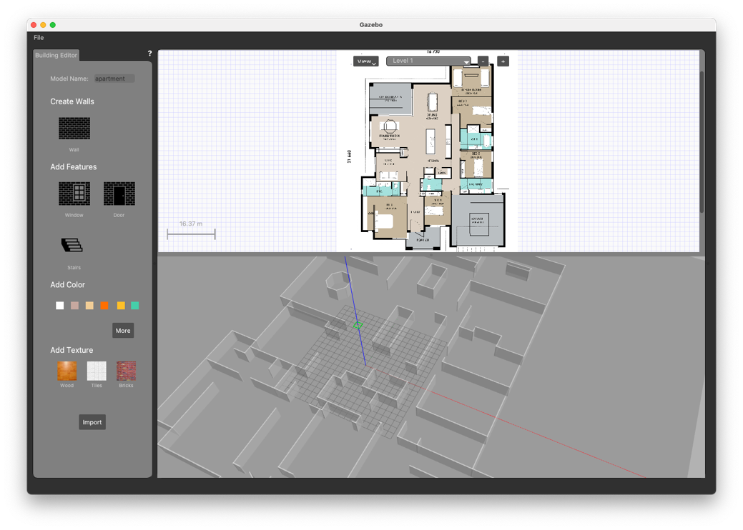

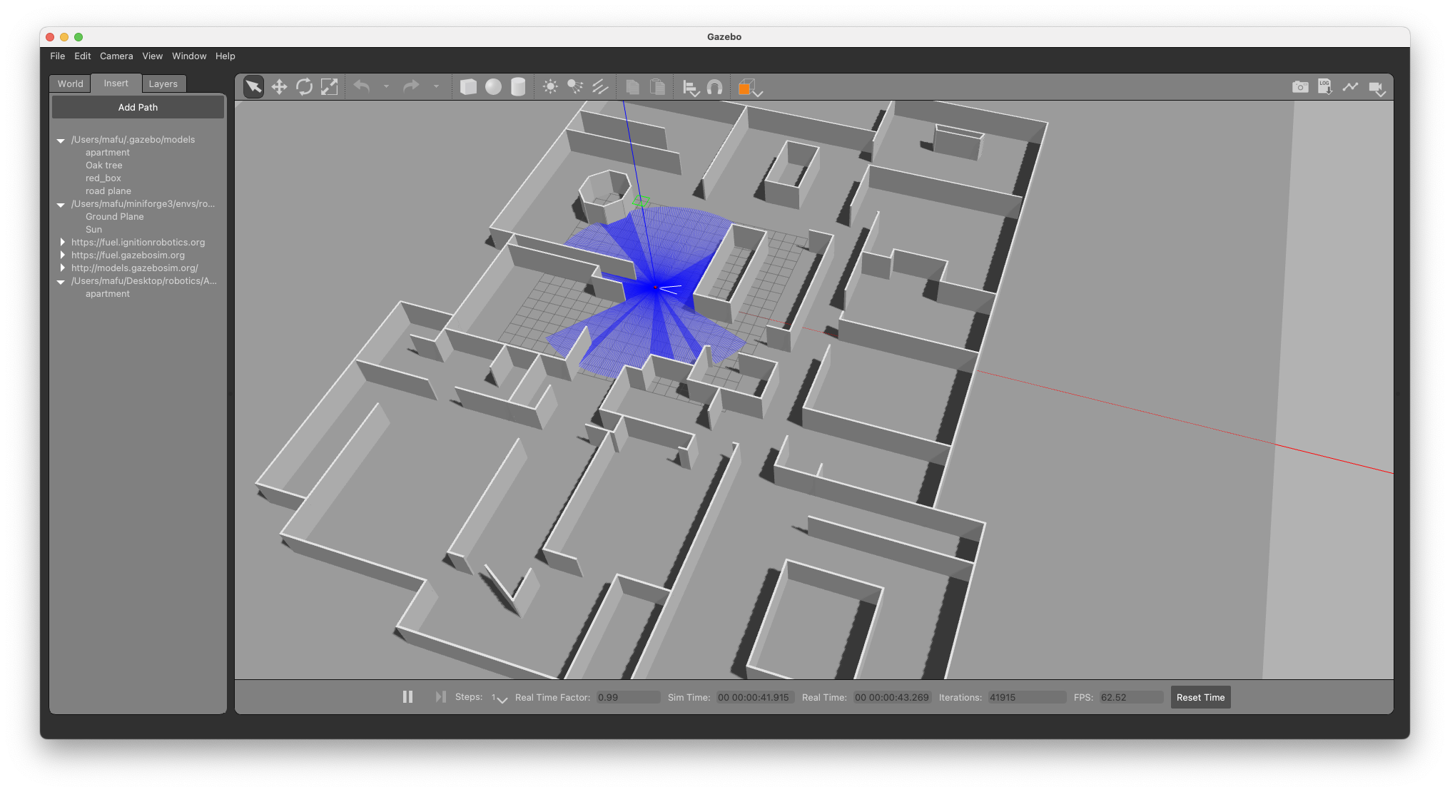

1. Take your blueprint and build an occupancy map that you can use with the RRT code from one of the labs. You should take the jpeg of your map and manually mark the walls (eliminating the objects that you did not include in your Gazebo world model). Once you have an occupancy map (similar to the one you created in the earlier lab), write code to/use some paint program to dilate all obstacles by a distance r, which corresponds to the radius of the Laser Robot. Dilation is relatively straightforward. Process every pixel in the occupancy map, and if it is is adjacent to an occupied location, make it occupied after a pass through the map. This will dilate the map by one cell (whatever size cell you might have used.  Dilate by the radius of the robot. Note that OpenCV has built in functions to do dilation, but you can easily do this by writing the code yourself. Augment your code from the lab so that you can take the pose information from Gazebo and use that as a start location on the map, and choose a goal location on the map, and produce a set of waypoints that if the robot was to follow using straight lines would get the robot from the start to the goal [40 marks].

